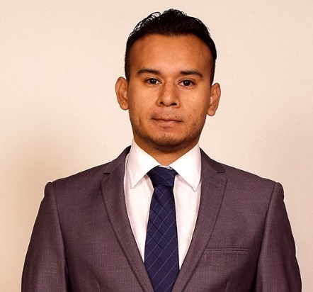
EDGAR ISRAEL GONZALEZ SALGADO
Senior Full Stack Engineer – AWS Cloud Ready

ABOUT ME
Developer specialized in delivering high-quality technological solutions through software development. Skilled in solving complex problems across multiple platforms and domains, using various programming languages. My strong focus on organization and management, combined with solid technical capabilities, allows me to contribute effectively across different technological areas and participate with precision and efficiency in each stage of the development lifecycle. I have 11 years of experience in the field.

The main technologies and programming languages used throughout my career include:

Databases: MySQL, Oracle, SQL Server. T-SQL
Frontend: Frontend: HTML5, CSS3, Responsive Web Design, Javascript, Angular 8, Angular 12
Java SE: JFlex, Cup, JasperReports, Process automation, Android mobile development.
Java EE: Spring boot (Hibernate, JPA, Maven, Spring Security), servicios web (REST, SOAP), microservicios (MicroProfile).
NET: ASP.NET MVC, Entity Framework, web services, SQL Reporting Services, C# desktop applications, VB, process or task automation, SSIS ETL processes, Xamarin Forms mobile development.
PHP: framework. Web services(SOAP, REST), CMS: Wordpress.
Servers: IIS, Apache, WildFly, Node.js, Ngenx, Shell-script Linux
Infrastructure: (Networking, servicios de infraestructura), Kubernates, Terraform, docker
Version Control: Git (experience with GitLab and GitKraken)
CI/CD: Jenkins (pipeline automation and deployment orchestration)

Telephone: 55 2204 0665
https://cv-liard-one.vercel.app
Delegación Cuauhtémoc, CDMX

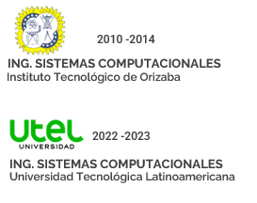
EDUCATION

EXPERIENCE
ZS
AI
SENIOR DEVELOPER
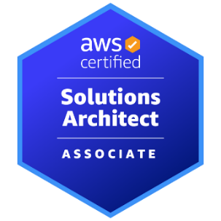
Cloud Infrastructure and Integrations – Bancoppel
AWS (Networking, infrastructure services)
Docker
Spring Boot (Java), CodeIgniter (PHP), MySQL
Kubernetes
Linux shell scripting
Web services: REST, SOAP
Version control: Git
Draw.io

Collaboration in infrastructure project management and planning, including deliverables definition, scheduling, and coordination across teams.

Infrastructure as Code (IaC) development using Terraform and Packer to create, configure, and version AWS infrastructure in a reproducible and automated way, enabling full deployment of cloud environments and services.

Development of Java applications and microservices with Spring Boot, containerized with Docker and deployed to Kubernetes (EKS), including end-to-end validation.

Development of internal applications for operational optimization and process improvement within the department.

Integration testing and communication with AWS services, including automated testing using shell scripts.

Architecture and workflow documentation using Draw.io.
COPPEL – February 20, 2024 – Present

https://www.credly.com/badges/f8195333-4f11-4d3c-be00-79b6a28c48d8/linked_in_profile

FULL STACK DEVELOPER
IMSS – July 2023 – January 2024
WTW – March 2023 – June 2023
SOFTWARE ENGINEER
SUAP Project (Unified Loan Management System)

During my participation in a project for the Mexican Social Security Institute (IMSS), I contributed to the development of a credit restructuring module intended for retired personnel and employees of IMSS nationwide. This module enabled the transfer of loans between financial institutions, automated document management, and the generation of customized reports. My role included implementing key features, as well as ensuring operational efficiency and data security.

Technologies:

• Databases: relational (Oracle).
• Application development: Express, Node.js, Angular.
• Java web application development: REST microservices (MicroProfile, Maven), JasperReports reporting.
• Servers: Apache, WildFly, Node.js, Nginx.
• Version control: Git.

IBIS PROJECT

Development of a strategic international project for Willis Towers Watson (WTW), with a strong focus on the Colombian market and its financial sector. My primary responsibility was to design and implement a comprehensive credit management module, covering the entire lifecycle from initial evaluation to final approval, adapted to local regulations and business practices in Colombia. This included the implementation of prospect evaluation algorithms, commission calculation systems, and document management workflows aligned with Colombian compliance requirements.

Technologies:

• Databases: SQL Server, T-SQL
• Web development: Windows Forms, jQuery (DevExpress)
• Desktop applications (DevExpress)
• Version control: GIT
HGSOFT – August 1, 2017 – June 29, 2018
FULL STACK DEVELOPER
- Process and task automation in Java (Maven, Commons CLI, Zip4j, Commons IO FileUtils, Joda-Time)
- Frontend and backend updates for WordPress websites
- Development of modules in Joomla
- Clinical system: Patient records, medication management, medical history, sales and control, daily inventory, income inventory, prescription and receipt printing (developed in PHP, MySQL)
- Self-service kiosk systems: Touchscreen terminals enabling payment of various services, customer registration, loans and investments management, loan details, card reader support, printing, amortization tables for Caja Yanga. WPF application with C#
- Development of web systems in PHP (CodeIgniter and Laravel), REST web services, relational databases, responsive web design, Git

Clients: Ciberburo, Fovissste, Infonavit, Mejoravit, Caja Yanga
FREELANCE- 2014 - 2017

FULL STACK DEVELOPER
PROGRAMMER ANALYST
J GARCIA LOPEZ – July 2, 2018 – September 17, 2021
AEROMAR – September 2021 – February 2023
FULL STACK DEVELOPER
I analyze, together with my team, the best solutions for internal problems and improvements within the company. I design and develop databases and software from scratch.

- Desktop applications: C#, VB.
- Mobile applications: Xamarin Forms.
- Relational databases: SQL Server, MySQL.
- Automated processes: C#, T-SQL.
- Reports: SQL Reporting Services.
- Custom web systems: ASP.NET (MVC, Entity Framework).
- Web services: REST, SOAP (.NET).
- Responsive web design.
- PHP: WordPress (plugin development), REST services.
- ERP activities: SAP Business One, S/4 HANA.
Development of technology solutions through software:

- Databases: relational (SQL Server, MySQL), non-relational (Firebase).
- Application development: Express, Node.js, Angular.
- Development of applications and web services (REST, SOAP) in Java Spring Boot (Hibernate, JPA, Maven, Spring Security).
- Responsive web design and layout.
- ETL processes using SSIS.
- Development of web services and applications in PHP, native code or frameworks (CodeIgniter).
- AWS: EC2.
- Version control using Git (GitLab, GitKraken).

Summary of Activities:
- Development of Android mobile applications using Java
- Development of web services (SOAP, REST)
- Development of various PHP modules
- Relational databases (MySQL, SQL Server)
- Responsive web layout and design

Clients: Biossmann, Casaplarre, Ganadera Gilio, Totems

